Lab Governance and Policy – Lab 02b Manage Governance via Azure Policy

Task 1: Create and assign tags via the Azure portal

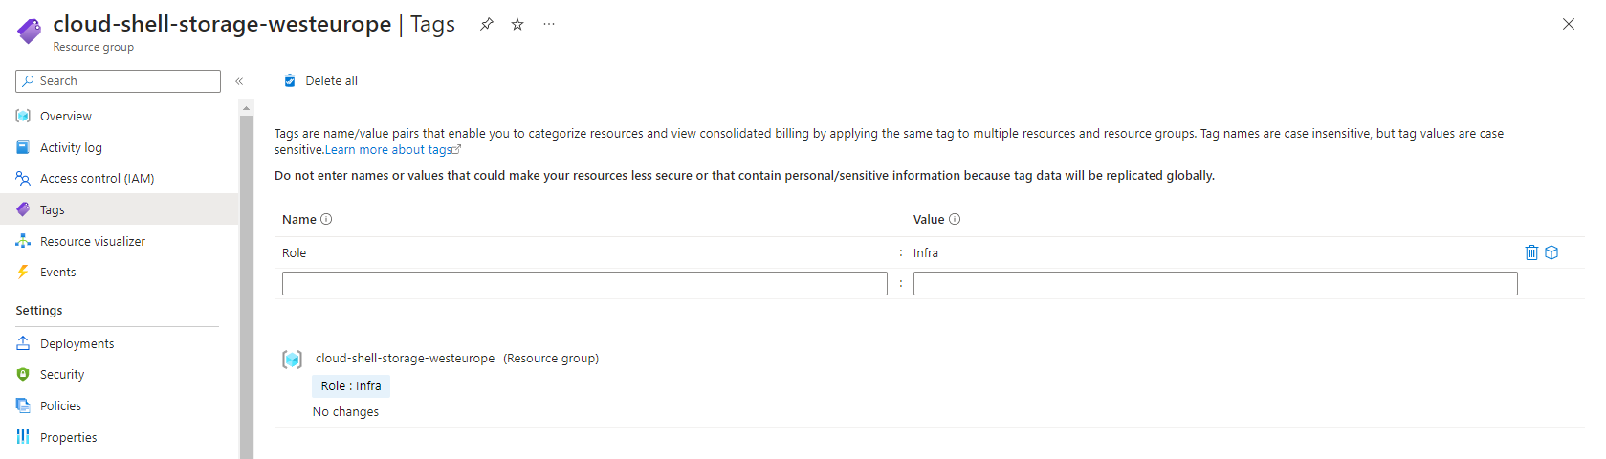

Assigning tags on the resource group which hosts the storage account for the cloud shell.

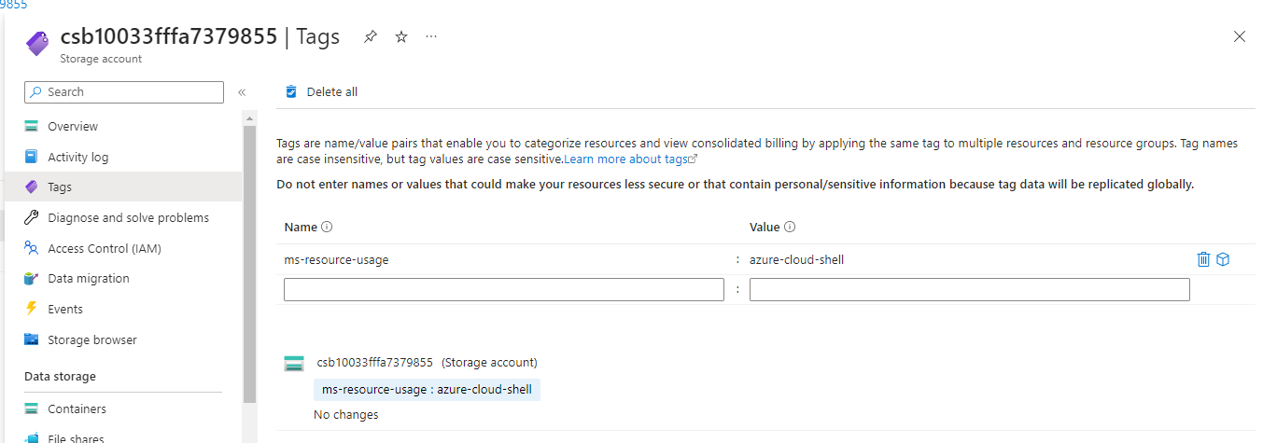

Checking to see if tags assigned to the resource group are inherited by the resources under them - resource level (storage account).  
Note: they are not by default, there needs to be a policy of some kind assigned, to prevent creating a resource without specific tags or populating the empty fields during creation with predetermined “inherited” tags. Additionally note that previously created resources can pe updated to have the new requirement from the policy by doing a “remediation task” on already created resources. (only for resources with missing tags, if they have existing they won’t be changed if we run the policy against the already existing resources).

Task 2: Enforce tagging via an Azure policy

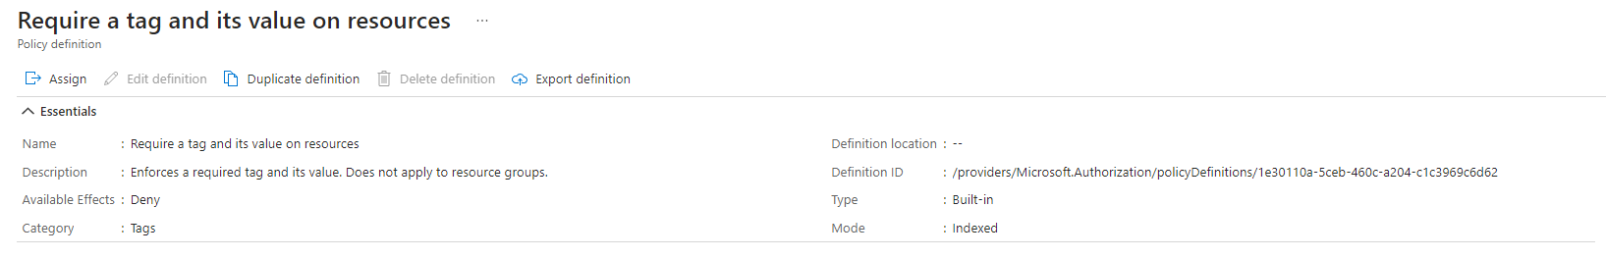

Reviewing the requested policy in first part of task 2.

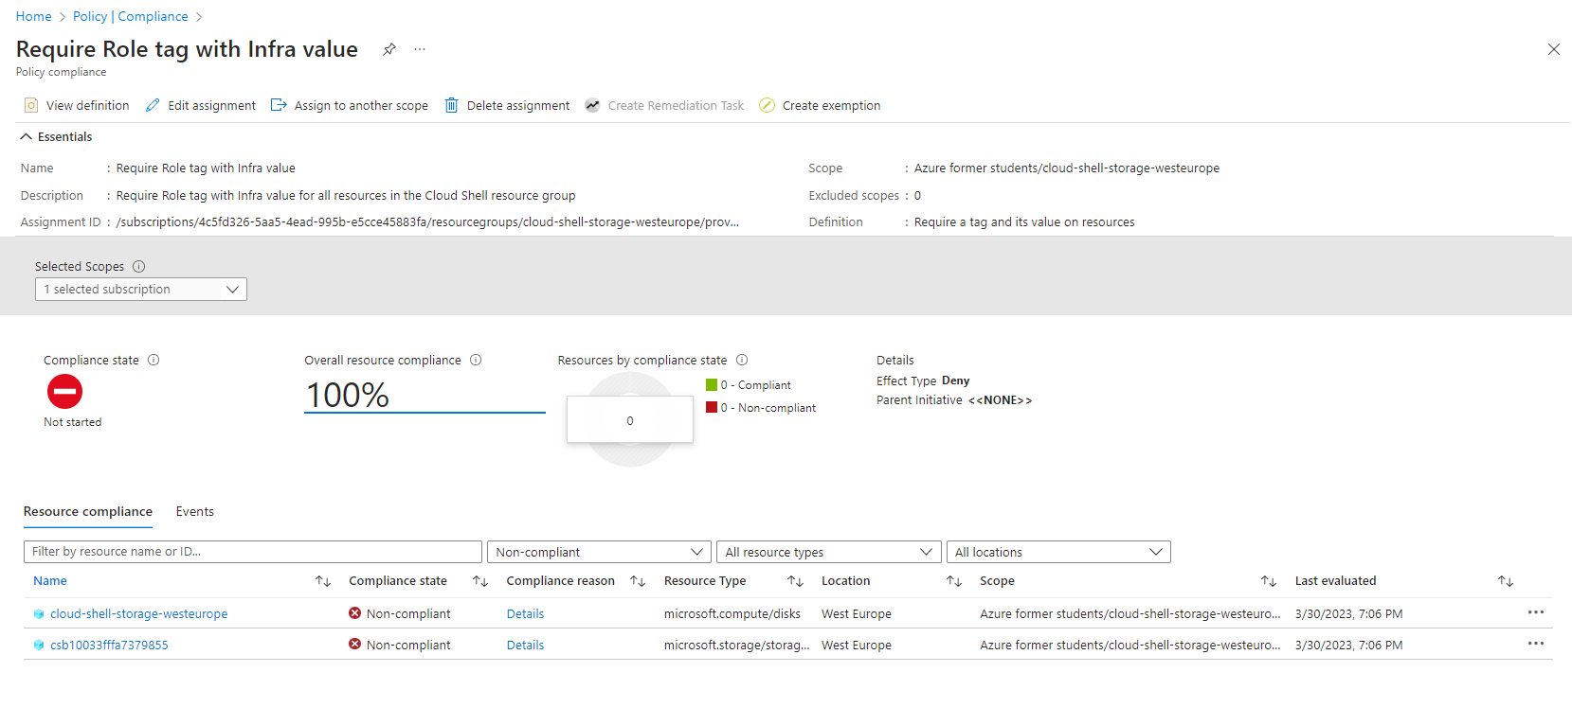

Creating the requested policy which requires that newly created resources must have a tag with the key role and value infra assigned at creation time, assigning the policy to the current subscription scope. Policies can be applied to the management group level, subscription level or resource group level (all resources in the RG to have the tag – most commonly used).

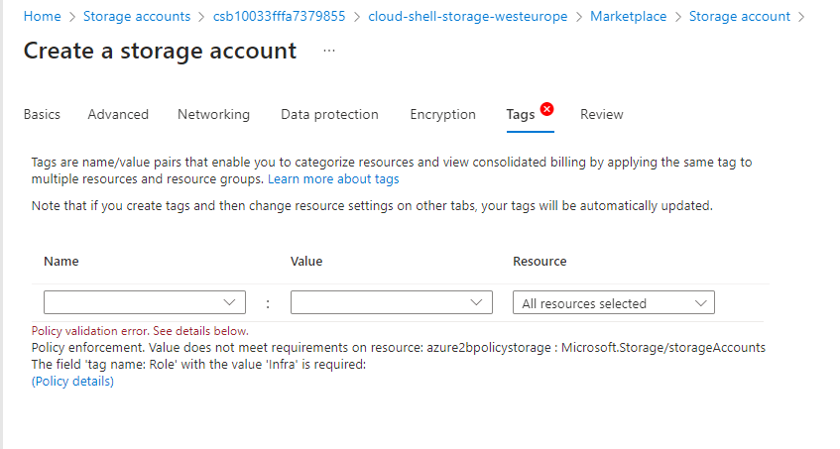

While attempting to create a new storage account under the same Resource group, unlike the example from the az-104 lab manual for this lab where the deployments fails it did not let me create the resource group which is the expected behavior and it does not let me go past the review stage.

Task 3: Apply tagging via an Azure policy

Reviewing the requested policy in second part of task 2.

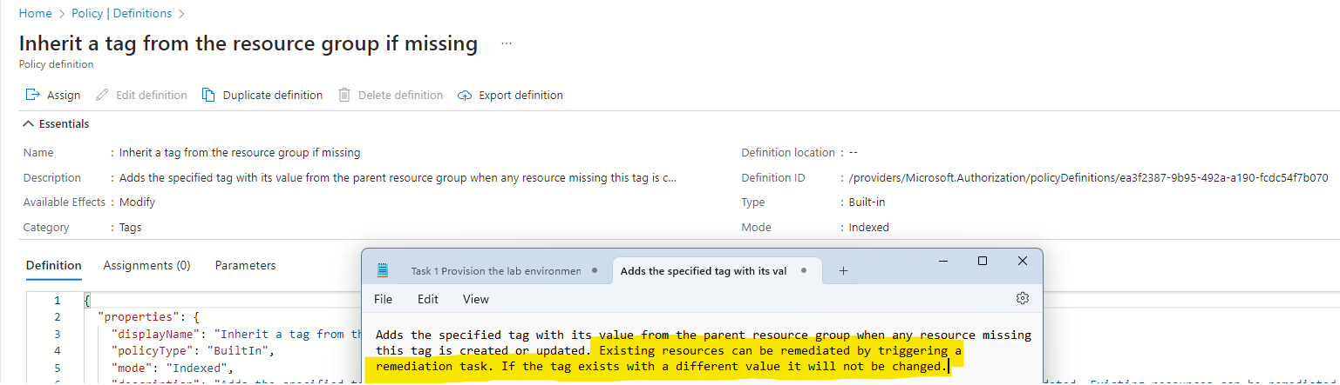

After deleting the previous policy we are creating a new one with the definition that if during time of creation the resource being created does not have a tag assigned it will be inherited from the resource group, scope is once again the resource group in question.

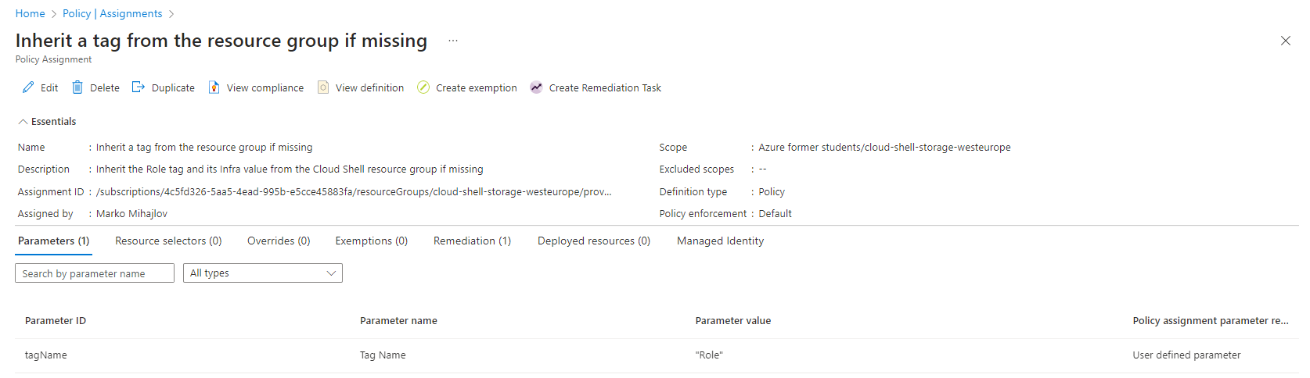

Reviewing the created policy.

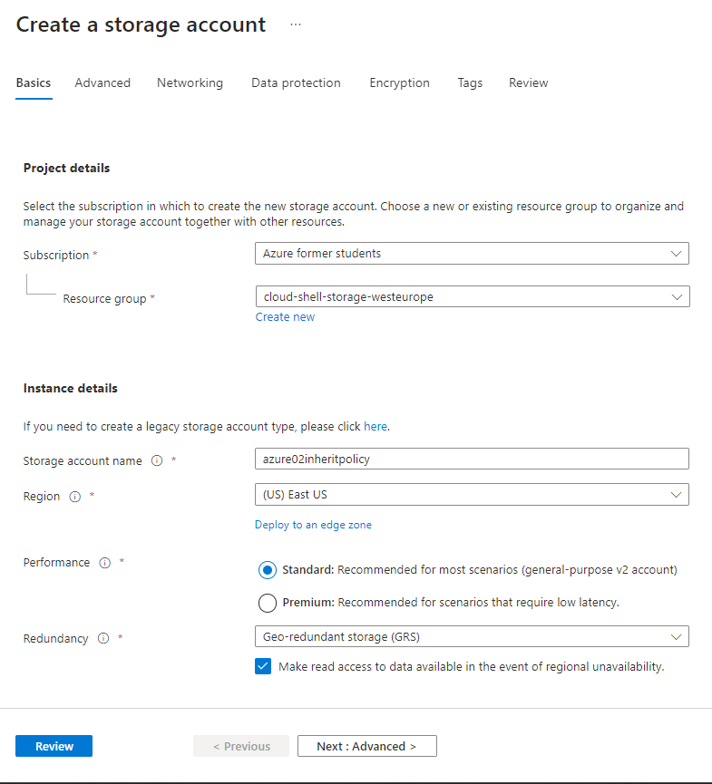

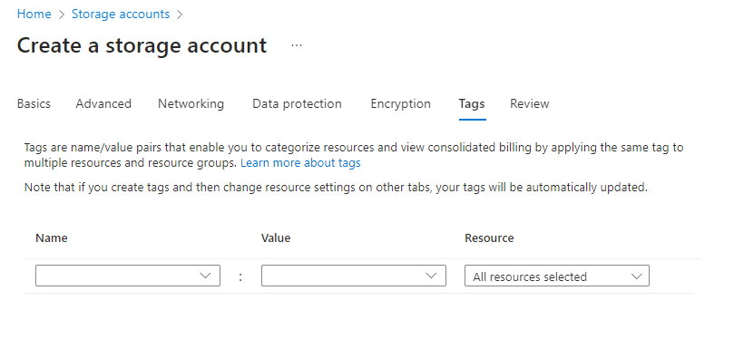

Review is passed this time although there are no resource tags assigned at time of creation.

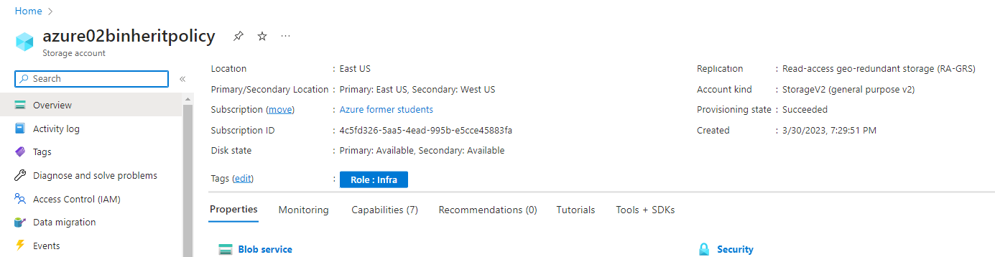

After creation we can see that the tags are inherited from the resource group because during assigning the policy definition to the resource group scope we defined remediation task - **Inherit a tag from the resource group if missing.**

**End of File.**